Instructions
To create a new account, you will need to have the account activation letter provided by your school to hand. You will also need to be able to access your email, as your email address will become your new username and is used for the verification process.
If you have lost your activation letter or have not yet received it, please get in touch with your school.
IMPORTANT Users with an existing ParentPay account should log in and follow the 'add a child' procedure, rather than registering a new account.
- Navigate to www.parentpay.com
- Select Menu, Parent Login, then Parent Login.
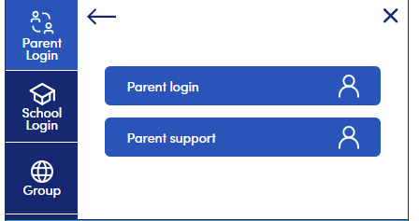
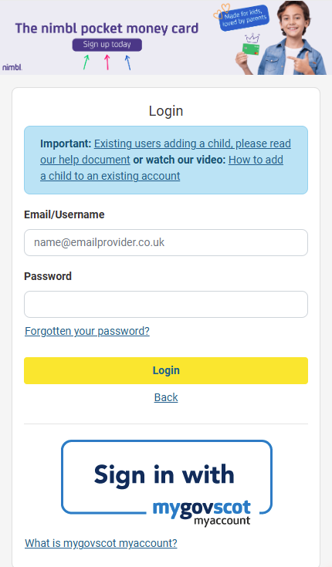
- Enter the username and password shown on your account activation letter and select Login.
INFORMATION The user details are case-sensitive and one-time use only. This will become invalid after account activation.
- Confirm the details are correct, then enter the date of birth for your child and click Confirm.
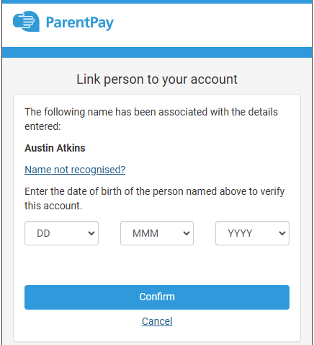
- Follow the on-screen instructions to complete and successfully activate the account.
- Enter your name, email address, and create a password for your account (your email address will become your username).
- Carefully read the ParentPay terms and conditions and check the box to accept them, then click Activate account.
- A verification email will be sent to you.
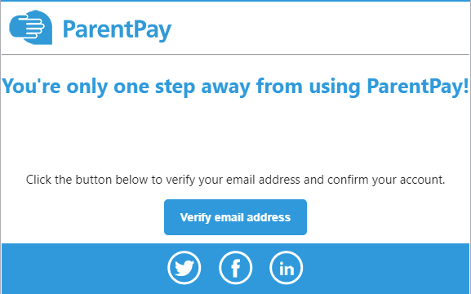
IMPORTANT You will need to click on the link within the email to complete the process and start using your account.
- You have now successfully activated your ParentPay account.

